Collaborative Coding & GitHub Workflow Simulation

Group 6

22BCS056 KOYA SIVA SAI

22BCS057 KRISHNA JOSHI

22BCS058 KUNAL SHARMA

22BCS060 LODE HARI KIRAN

22BCS065 MAMIDI MANAS

# Github Repo Setup :

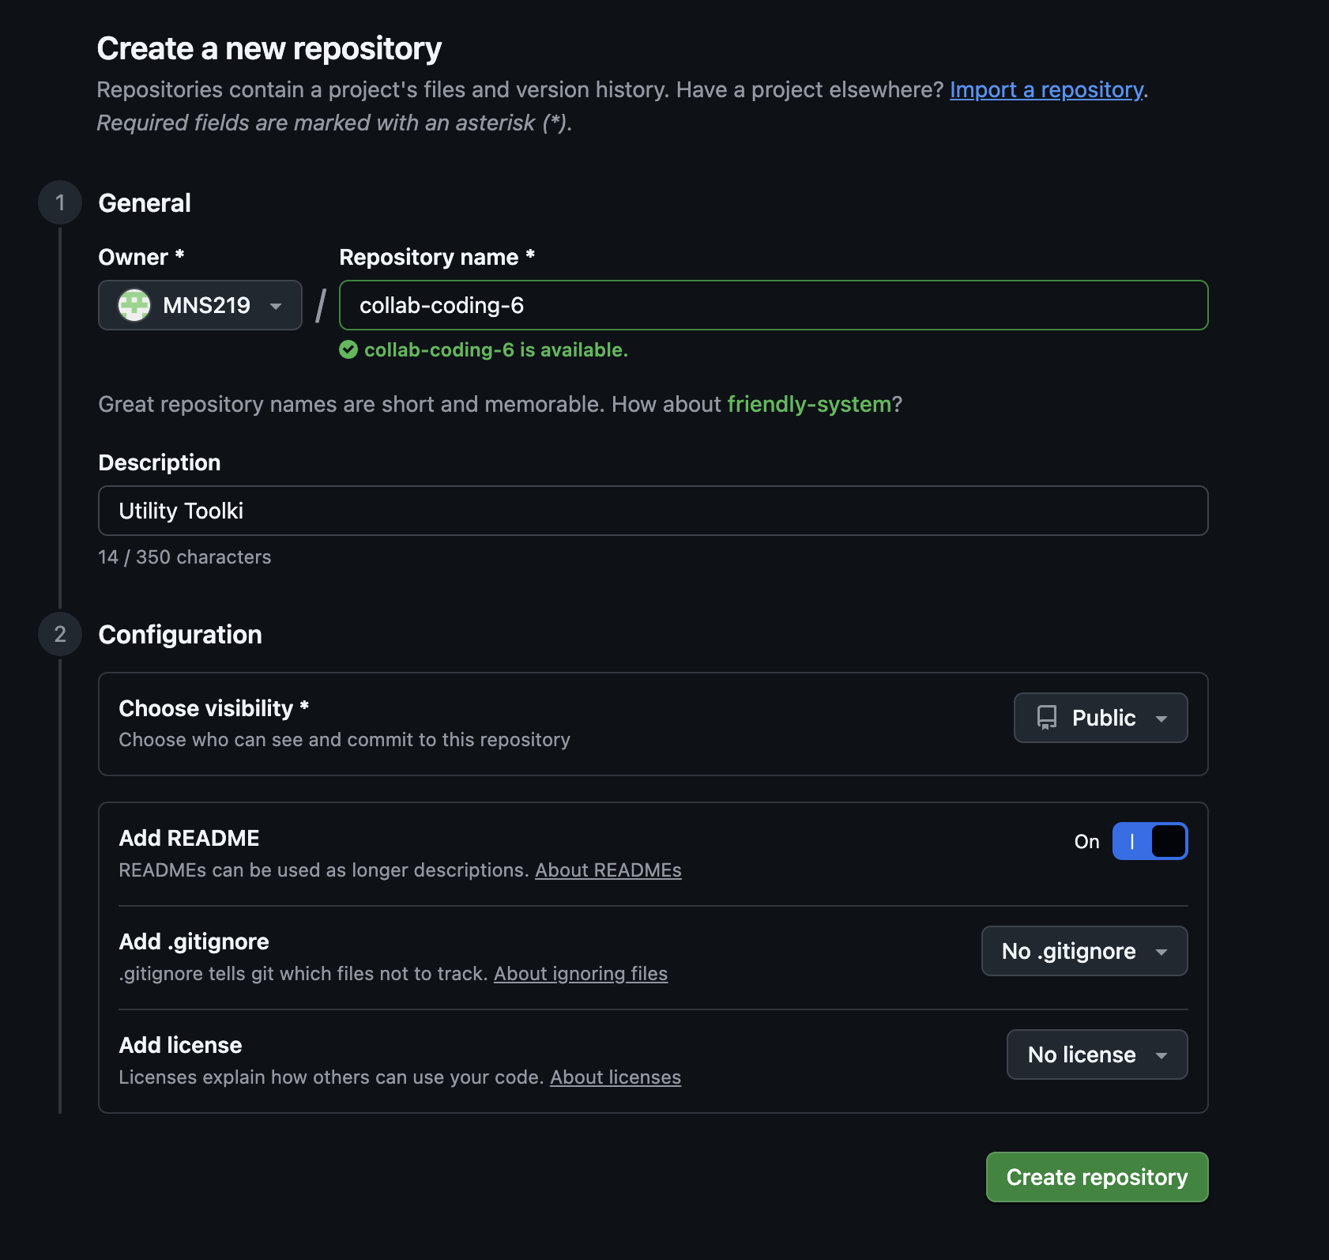

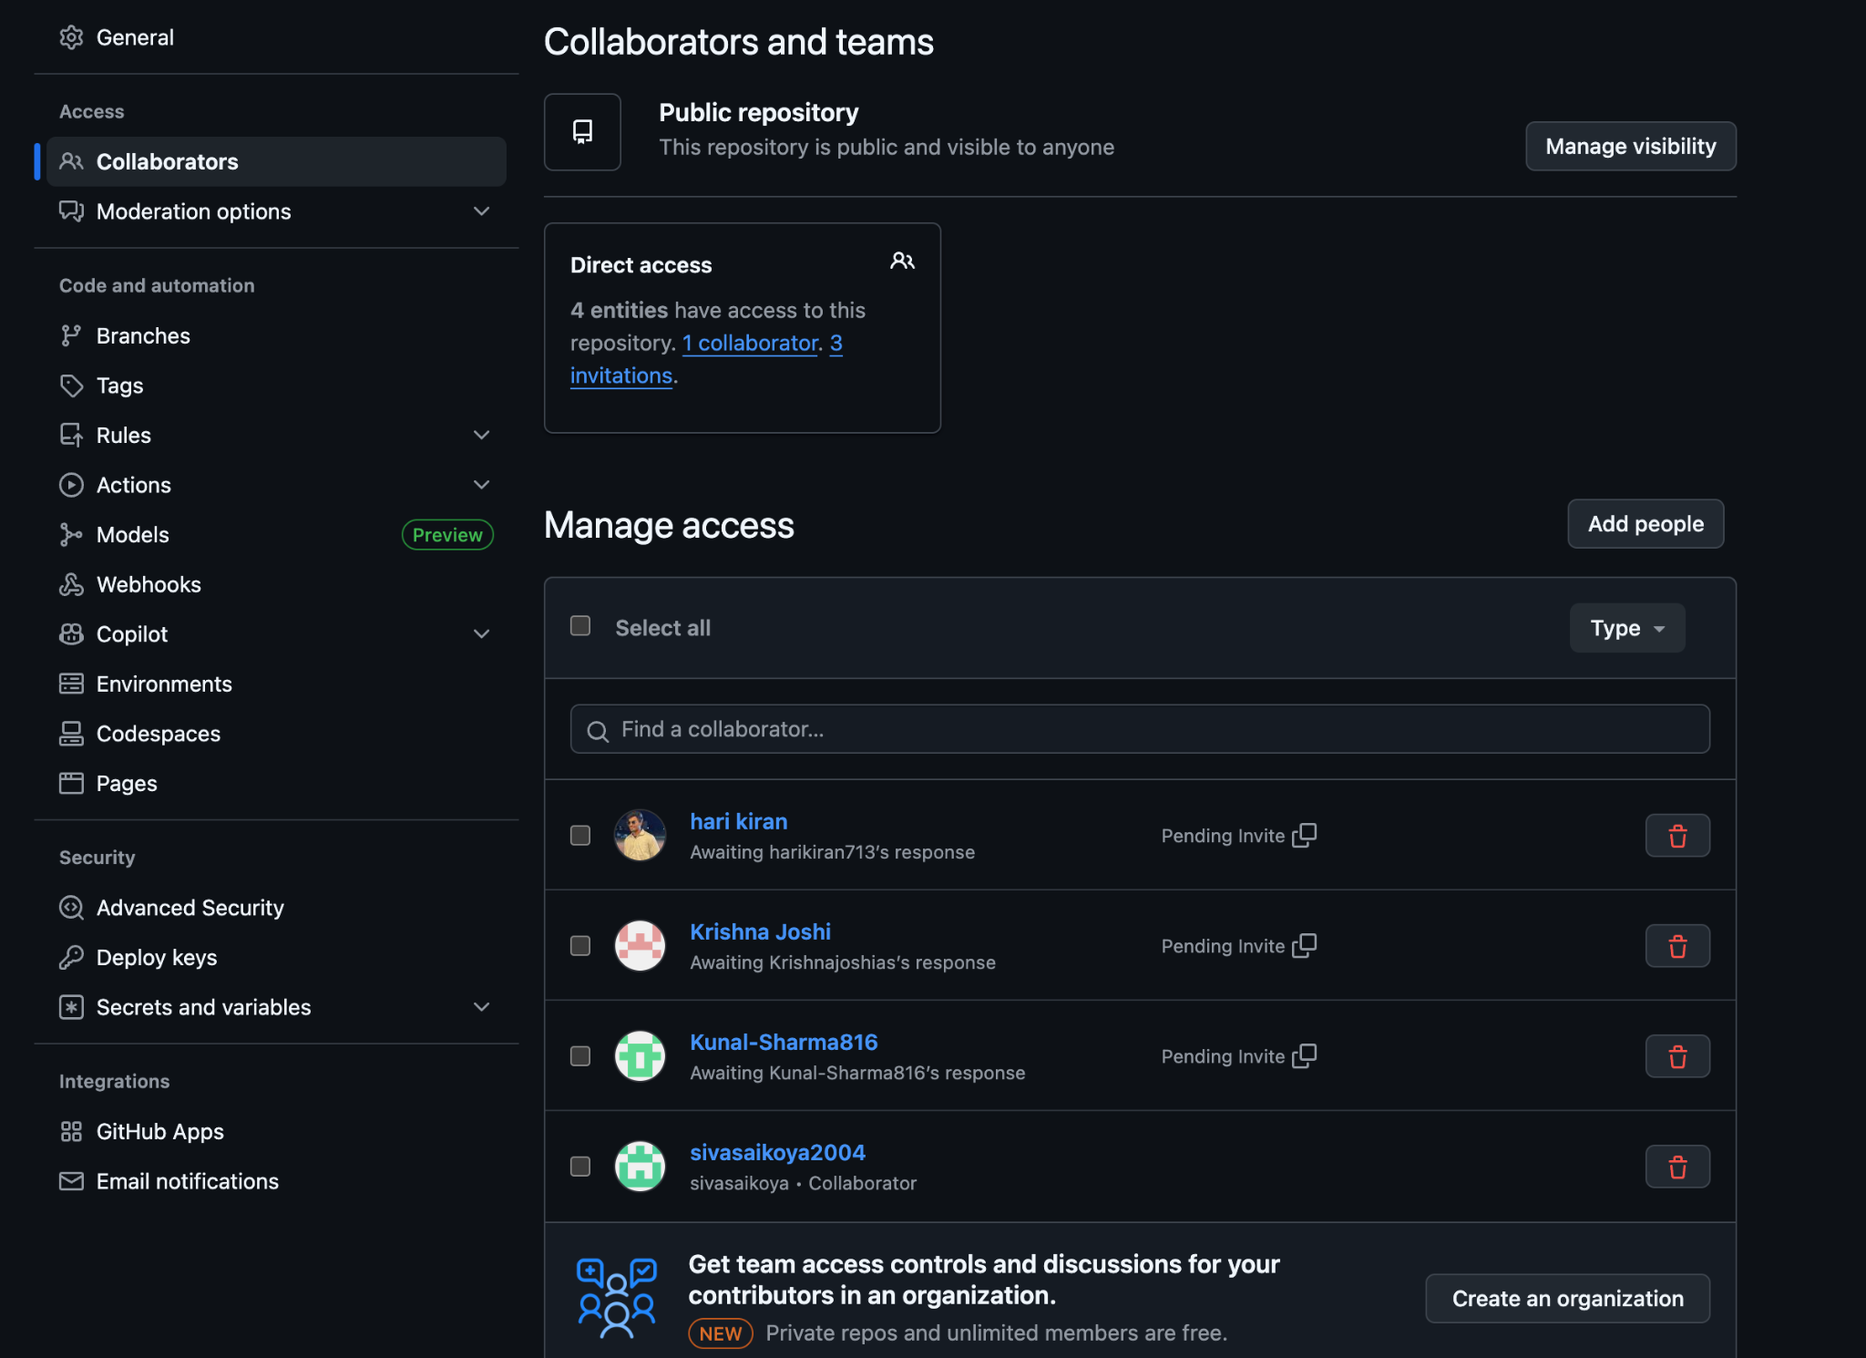

# Branching and Commits :

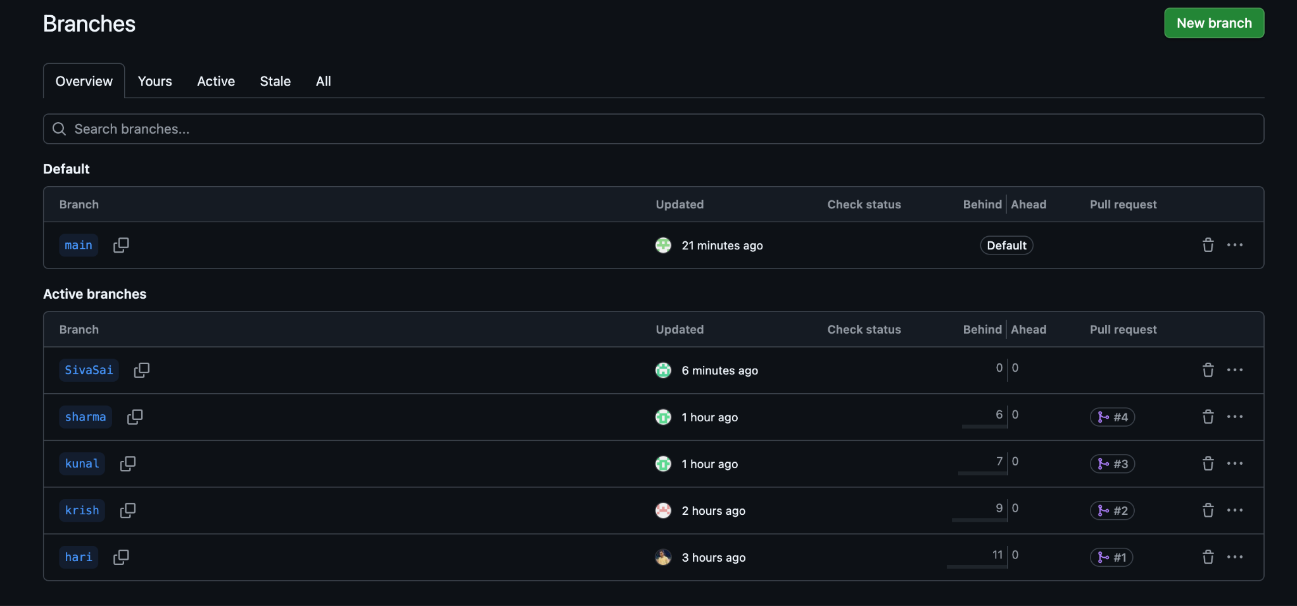

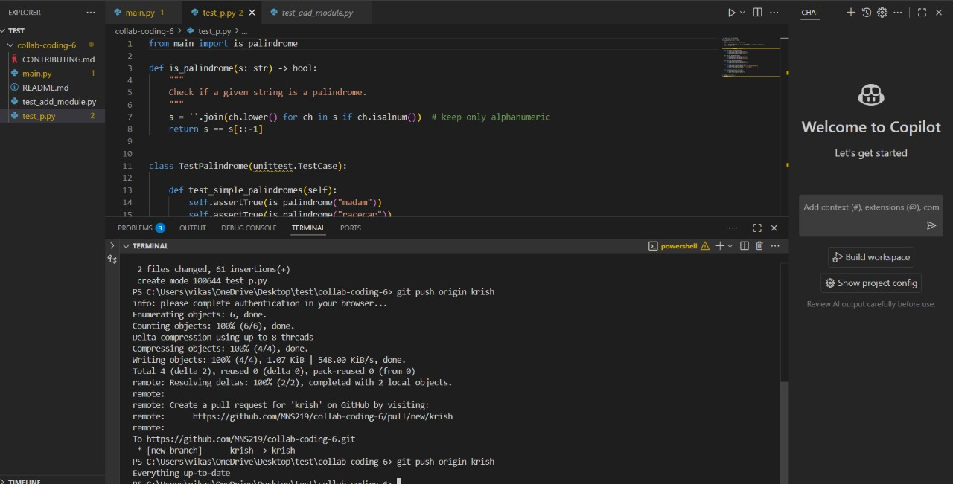

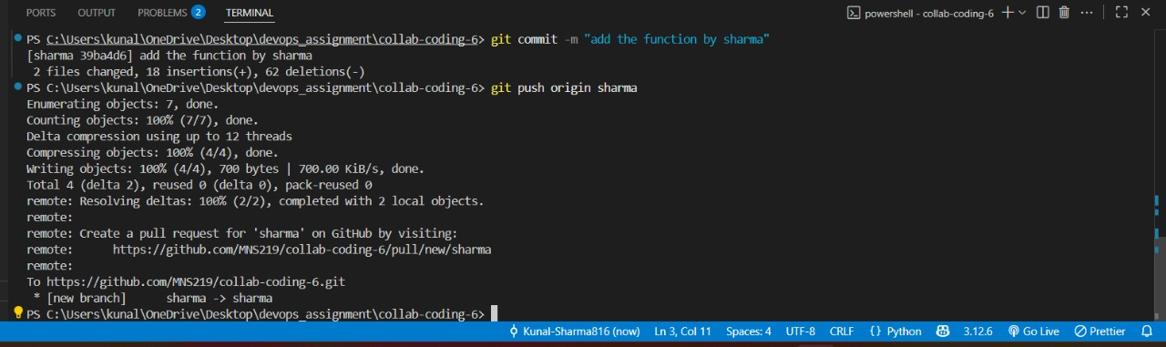

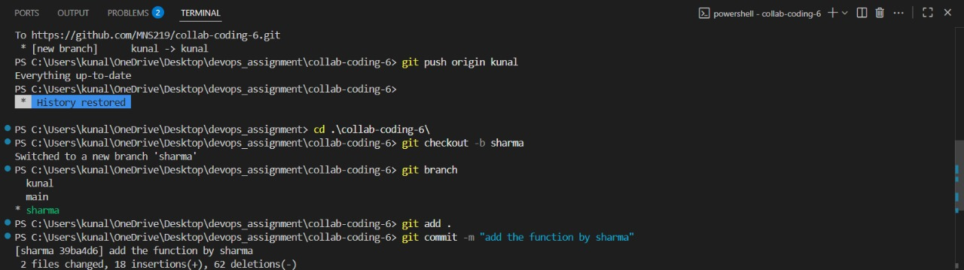

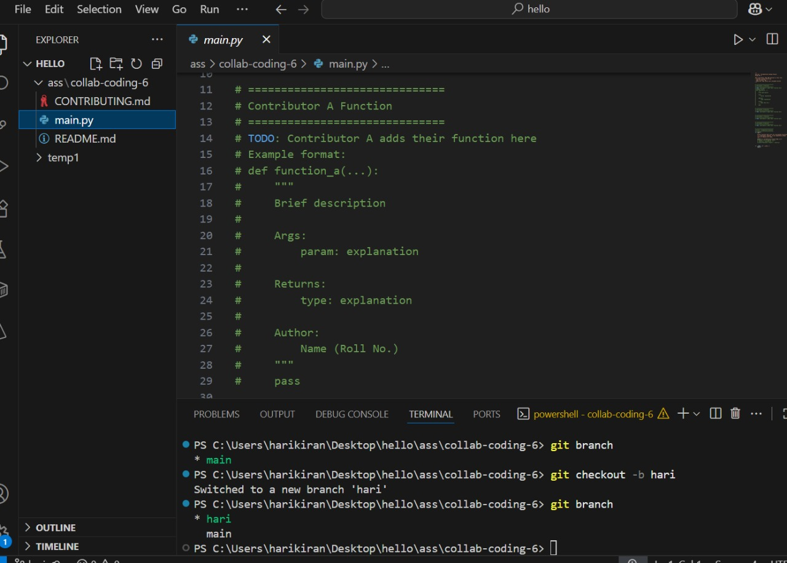

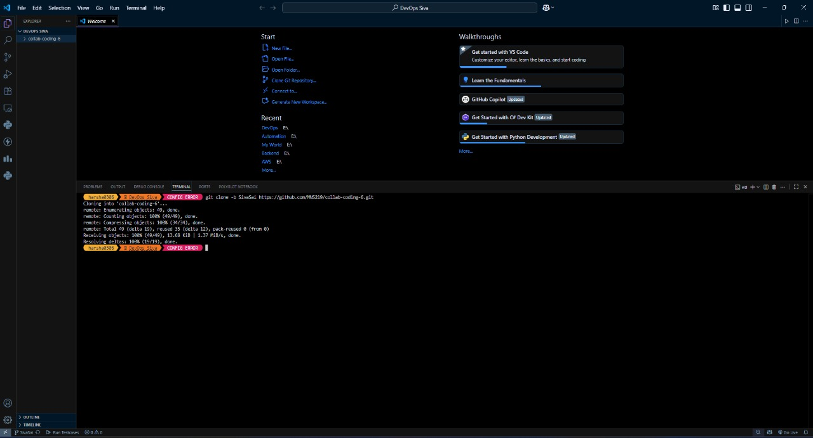

# 

# Pull Requests :

